

**USER MANUAL**

**Table of Contents**

1. **Welcome**
   1. **Introduction to Gamebook**
2. **Startup**
   1. **Navigating**
   2. **Signup**
3. **Features**
   1. **Creating Notes**
   2. **Deleting Notes**
   3. **Formatting Notes**
   4. **Playing Games**
4. **Welcome**
5. **Introduction to Gamebook**

Welcome to Gamebook!

Gamebook is our great note-taking application that helps you pay attention while in-class or in that boring meeting.

You have plenty of storage to take all the notes you need, as well as a great amount of formatting tools to help present everything effectively.

While taking notes, there are games that pop-up that you can play, if you feel like you are getting bored at a certain point.

These games are designed to be played for a short amount of time, but to wake you up and get your attention so you can continue being productive!

Everything you need to know about using the application will be next.

Welcome to your new, reliable and productive note taking application!

* The Gamebook Team

1. **Startup**
2. **Navigation**

In order to get to the application, there is a specific website. If you are hosting this application yourself, see the Systems Manual to figure out which website to connect to.

When you are at the application, you get our homepage:



If you already have an account, you can sign in through here. If not, you may also easily sign up for one.

1. **Signup**

If you do not have an account, signing up is easy!

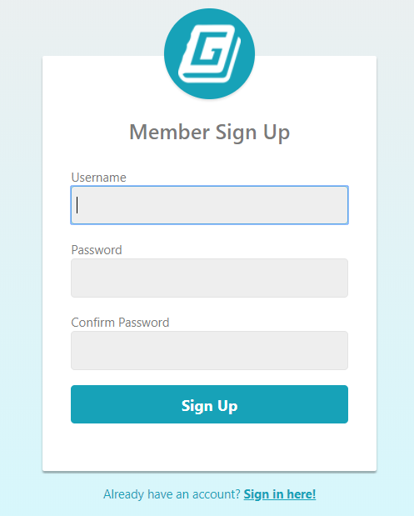

You will be presented with this form.

You can create any username you’d like and use this to login to the website.

Any password you create must be at least 8 characters, not be a common password, as well as not be too similar to the username.

This will be used to keep your notes safe, make sure you always remember it!

1. **Features**
2. **Creating Notes**

When you’re logged in, you’ll be presented with a screen showing your notes, if you have any.



You may create notes by either clicking the “Add New Note” button on the menu bar, or click the link saying “You do not have any notes”

This will bring you to your notes, so you can begin your note taking process!

1. **Deleting Notes**

If you’re ready to get rid of a note, in your note menu, there’s a delete button specifically for that, on the right side of the note!



1. **Formatting Notes**

There are plenty of tools to use to format your notes, and the best part, it autosaves everything for you.

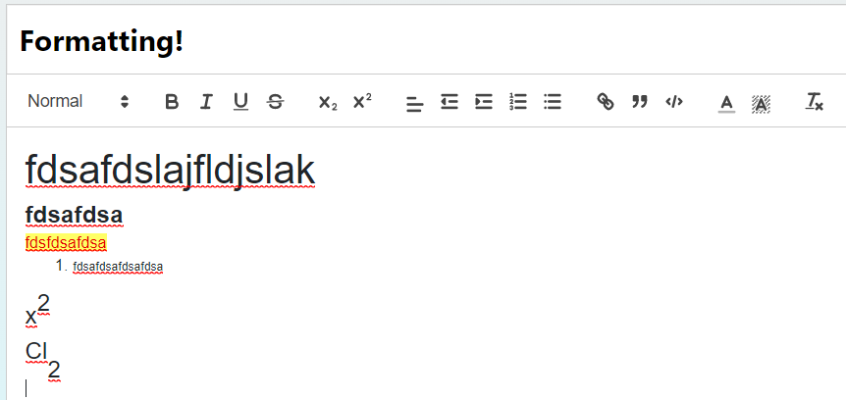

Going from left to right on this bar here are the features:

* Changing Text Size
* Bold, Italics, Underlining, Strikethrough
* Subscripts, Superscripts
* Text Alignment, Indenting, Bullets, Numbering
* Hyperlinks, Quotations, Code Formatting
* Text Color, Text Highlighting
* Remove Formatting

Try out all of these formatting tools for yourself!

1. **Playing Games**

When games are ready to be played, a box will appear at the bottom telling you.



Pressing the key combination or clicking this box will trigger a random game to be played.

For all games, you may click Esc or the dialogue box in the bottom left to abruptly exit the game. Otherwise you will have a timer to play the game to get your attention.

Bic-Bac-Boe

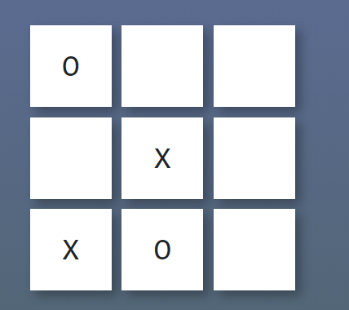

Click on the tiles, and try to get 3 X’s in a row. In this game, you play against the computer, where the computer places O’s on the board. You keep playing rounds until the timer runs out.

Snake

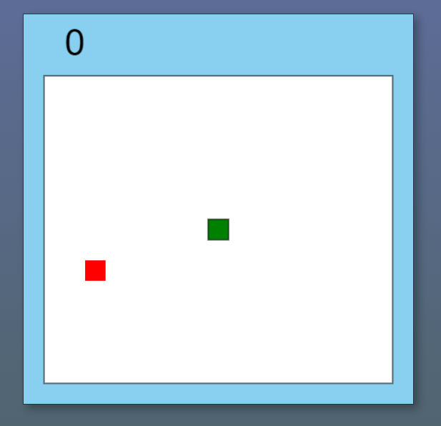

Use the arrow keys (or if on mobile, swipe your finger) to collect the dots so your snake grows larger. Try not to bump into any walls or run into the snake itself!

**Thank you for Using Gamebook!**

**We hope you enjoy!**